

_________________________________________________________________________

**Altizachen** - Second-hand products website - Phase B

**Project Code Number:** 23-1-D-12

**Hadar Iluz:** [Iluzhadar@gmail.com](mailto:Iluzhadar@gmail.com)

**Matan Ben-Hayon:** [Matan012@gmail.com](mailto:Matan012@gmail.com)

**Supervisor: Zeev Brazily**, [zbarzily@braude.ac.il](mailto:zbarzily@braude.ac.il)

**Git:** <https://github.com/IluzHadar/Altizachen>

**Table Of Contents**

Abstract 5

1. Introduction 5

1.1 Organization of the paper- 5

1.2 Scope of the project 6

1.3 Project’s stakeholders 6

1.4 Project’s code 7

1.5 Altizachen website 7

2. Background and Related Work 7

2.1 Maintaining an ecological environment 7

2.2 Related works 7

2.2.1 **Yad 2** 7

2.2.2 **Facebook Groups** 7

2.2.3 **Bazaars and markets for buying second hand** 8

2.2.4 **Agora** 8

3. Engineering process 8

3.1 Overview of development tools 8

3.1.1 Agile Development Method 8

3.1.2 Trello 9

3.1.3 Source Tree-GIT 10

3.1.4 Client-server 12

3.2 System components 13

3.2.1 Cloud computing 13

3.2.2 MongoDB 13

3.2.3 ReactJS 14

3.2.4 React Router 14

3.2.5 React Bootstrap 14

3.2.6 Redux 14

3.2.7 Node.js 15

3.2.8 Express.js 15

3.2.9 Render 15

3.3 System Engineering Documents 16

3.3.1 Program structure description and runtime configuration 16

3.4 UML 17

3.4.1 Use Case Diagram 17

3.4.2 Class Diagram 18

3.4.3 Activity Diagrams 18

3.4.3.2 Edit product 19

3.5 System requirements 20

3.5.1 Login 20

3.5.2 Flow processes on the website and user’s actions 21

3.4 GUI Design 23

4 Challenges and solutions 38

4.1 Presentation of products with a common denominator – category: 38

4.2 Ad structure and user LIKE handling for each ad: 38

4.3 User rating system 38

4.4 As`s reviews structure: 38

5. Evaluation / Verification Plan 40

5.1 Unit Tests 40

5.2 Functionality testing 41

6. References 43

**Table Of Figures**

Figure 1 -Aglie 9

Figure 2 - Trello 10

Figure 3 - Source Tree-GIT 11

Figure 4 - Client Server 12

Figure 5 - Architecture and interfaces 13

Figure 6 - Use Case Diagram 17

Figure 7 - Class Diagram 18

Figure 8 - Upload new product activity diagram 18

Figure 9 - Edit product activity diagram 19

Figure 10 sign in screen- error message 23

Figure 11 Registration screen 23

Figure 12 create new user - error message 24

Figure 13 Sign In -error incorrect format message 24

Figure 14 Access the user's location by IP 25

Figure 15 sorted ad by locstion 25

Figure 16 Home screen for not VIP user 26

Figure 17 Home screen for VIP/Admin - all active ads 27

Figure 18 Home screen for VIP/Admin - VIP ads 27

Figure 19 View ad 28

Figure 20 View ad google maps 29

Figure 21 Edite ad screen 30

Figure 22 Edite ad in status of pause 31

Figure 23 Upload Product 32

Figure 24 Upload Product successfully message 32

Figure 25 personal info screen- alert 33

Figure 26 personal info screen 33

Figure 27 Admin menu 34

Figure 28 Admin management center 35

Figure 29 Admin management center - statistic 36

Figure 30 create new admin 37

Figure 31 Mobile view 37

**Tables**

Table 1 Unit Test 40

Table 2 Functionality Tests 42

# Abstract

The goal of our project idea came with the goal of maintaining an ecological environment and creating a connection between people who are interested in throwing away/donating objects and people with disabilities. The website ‘Altizachen’ enables people to share secondhand products and by that keep our earth safe. This website serves as a convenient platform for finding a solution for unused second-hand products. The site displays the ads for each user by sorting ads that are closest to him geographically and display the path from user location to the product location.

In our website the advertisers will be able to publish ads of the product, take a picture of the product and post the location of the product using google maps. The customers will be able to search for a product they are interested in among the various ads that will be published and arrive at the location of the product with google maps on our application.

In addition, users will be able to post comments, ask questions and like products and help other users get opinions about the advertiser with the help of a rating system we built that is based on user responses and likes.

# 1. Introduction

## 1.1 Organization of the paper-

1.1.1 In the first part we explain the motivation that brought us to the creation of this project and who the project's stakeholders are. In addition, a link to the project code and the website product found on the Internet is shown.

1.1.2 We explain why it is worthwhile for society to consume more second-hand products, the advantage of second-hand products such as protecting the planet and creating a healthier consumer culture.

Competing platforms are also described.

1.1.3 In this section the engineering process is described. All the technological tools used and how they contributed to the development process are presented.

Such as: Agile, Trello, Git. In addition, there is detail on the various system components and framework.

In addition to this section, there is a large section that refers to System Engineering Documents and it includes several important topics:

* Background on the preliminary research and the questionnaire distributed in part A of the project.
* UML diagrams.
* Functional and non-functional requirements of the system
* GUI and explanation of the various screens on the site.

1.1.4 The challenges we experienced in the development of the project and the solutions are described in the quadrants.

1.1.5 In this section we presented the execution of unit tests and system verification programs that help us maintain the system functionality correctly.

1.1.6 The section of references to the sources used for the development of the project.

## 1.2 Scope of the project

In recent years, consumers are choosing eco-friendly products when they shop, not only because it's a cheaper option but also because it helps preserve the environment for future generations. And above all, it promotes a new consumer culture.

Our main task is to expose more and more people to be guided by these needs.

For that, we have identified and defined requirements for a system that can manage donation of various objects that people do not need and are interested in donating. Our ‘moto’ is: “One person's unused object is another person's treasure.”

The project is a website contains two main actors: donors, customers.

The flow of the project is initially publishing an ad advertising a product by the donor, where the donation is any object in his possession that he wishes to throw away.

The customer sees all the objects available for him in his range, with the help of our system that shows to each user the ads sorted by distance from him by different categories, the customer decides if he finds a personal use for them.

The customer will select the object he wishes to take and will contact the donor/advertiser for the collection date.

The project's overall flow consists of several independent parts, we divided it to sections which describe in part [3].

## 1.3 Project’s stakeholders

**Registered users (donors) -** People that want to publish ads need to create a new user in the system. Only registered users can rank other donors, each user is rated according to same parameters such: number of ads that he publishes and rating from other user, which determined by the amount of likes per ad.

**Guest users (customers) -** People that are looking for products do not need to register to the application, and they can watch ads, navigate to products, and contact the advertisers with the help of the contact information that appears in each ad and the route that Google Maps shows.

**Admin -** The user has the same features as the administrator, but in addition he can perform additional actions in the system such as deleting ads that exist on the site, adding another administrator and using the statistics screen that helps him manage and control the site.

## 1.4 Project’s code

<https://github.com/IluzHadar/Altizachen>

## 1.5 Altizachen website

<https://altizachen123.onrender.com/>

# 2. Background and Related Work

In our globus there are many initiatives to protect the environment. One of them is the utilization of second-hand products.

Every object we use, and then throw it away takes years for it to decompose. Therefore, according to articles and studies which have been done on this subject, it is very important to reuse products.

## 2.1 Maintaining an ecological environment

Increasingly, consumers choose ecological products when they do their shopping, not only because it is a healthier option but also because it helps to sustain the environment for future generations.

Article [5] provides an empirical analysis of how consumers' behavior differs based on their level of ecological concern.

They are prepared to switch products for ecological reasons and stop buying products from companies that cause pollution. Finally, the article explores the potential implications of these findings for marketers and others interested in understanding and influencing consumer behavior.

In addition, the article number [6] examines the reasons why people shop second-hand, including financial considerations, environmental concerns, and the desire to find unique items. The article also examines the different types of second-hand stores that consumers visit, and the types of goods that they purchase.

## 2.2 Related works

### 2.2.1 **Yad 2**

The web site ‘Yad2’ helps people sell products they no longer need.   
In this website every user can publish ads for each product (by category), publish photos of the product and with whatever price he wants [4]. Every ad has the phone number of the advertiser, but the user can’t contact them through the site.

### 2.2.2 **Facebook Groups**

On the Facebook social network there are many groups of second-hand products.  
In these groups we can find publications of posts that contain photos and descriptions about the product. In these posts people can make public comments and contact the seller. But the advertisers are not always obliged to present all the details, so many consumers send repeated questions, and many do not receive an answer.

### 2.2.3 **Bazaars and markets for buying second hand**

Almost every city has bazaars and markets that offer different collections at reduced prices and sometimes even display goods for donation. All this is done in order to contribute to those who cannot afford such things themselves.

Usually, a large organization or the municipality itself organizes the collection and distribution. When the main goal is to help those in need along with the possibility of other citizens donating and passing products from hand to hand.

### 2.2.4 **Agora**

The ‘Agora’ website is an online social enterprise that connects people who want to give away things they don't need and people who are looking for them.

The site requires you to hand over at least one item every two months.

A site does not require mandatory fields such as image and details about the product. In addition, only those who are registered on the website can view the details of the advertiser and not necessarily get an opinion on it. Our system manages a user rating that can be viewed by every user and makes sure to post pictures in every ad and other important mandatory fields.

# 3. Engineering process

## 3.1 Overview of development tools

### 3.1.1 Agile Development Method

In order to find the best development method for us, we researched different methodologies such as: Agile and Waterfall. Our conclusion is that Agile is the most effective development methodology for our project.

The parameters considered for selecting the methodology were as follows:

- Minimum time for repair if a requirement changes.

- Developing tasks in small steps.

- Flexibility and response to changes.

Within this methodology, the project tasks are fragmented into smaller units that progress towards completion within designated work sessions known as sprints. Typically lasting from a few days to several weeks, these shorter work cycles provide adaptability for incorporating changes during the development process, even at its final stages. As a result, the utilization of the Agile methodology facilitated the release of an initial version of the system.

Upon reaching the coding phase of the project, we established a series of significant milestones to guide our progress throughout the semester. The initial milestone involved conducting experiments with the tools researched in phase A, followed by commencing the installation and server building phases. Simultaneously, we undertook tasks that could be executed concurrently, such as constructing the various predefined application screens on the frontend.

Upon completing this milestone, we transitioned to the second milestone, which encompassed implementing logic within the screens and facilitating bidirectional communication between the client and server through request handling. Subsequently, we revisited the defined requirements and commenced the implementation of tables in the database based on the constructed class diagram.

Eventually, we arrived at the culmination of this project. Despite encountering challenges along the way, the selected development methodology enabled us to proactively organize tasks and efficiently execute them independently of one another. This aspect proved crucial given the demanding time constraints compared to the extensive scope of work to be accomplished.

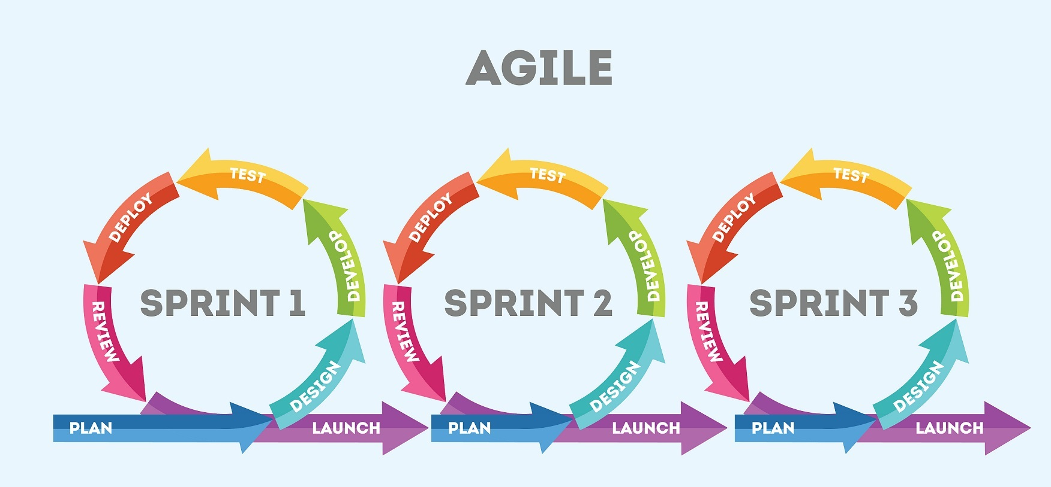

Figure -Aglie

### 3.1.2 Trello

Trello serves as a collaborative platform designed to streamline project management by organizing ongoing projects into boards. With a single glance, Trello provides an overview of the tasks at hand, assigns ownership, and tracks the progress within a workflow.[1]

As users, we have leveraged this tool to create customized templates tailored to the specific requirements of our project.

We have discovered that utilizing such a tool significantly enhances our ability, as a team or as individuals, to maintain control over tasks and deliverables within a large-scale project. This is particularly valuable when team members operate on different schedules and need to synchronize their efforts between the project and personal responsibilities.

Within Trello, we create dedicated cards for each week, encompassing comprehensive checklists outlining the necessary actions to be taken. These include engaging in discussions with supervisors, developing chapter outlines for the book, constructing UML diagrams, and implementing specific functionalities based on the predefined sprint structure. Moreover, supplementary lists offer a suggested breakdown of work by week, providing a clear path to reach crucial milestones.

Additionally, Trello allows us to establish research goals for exploring tools that may potentially be incorporated into our project. These goals are documented and can be seamlessly integrated into the project documentation. The tool also assists us in monitoring workload distribution, ensuring that tasks do not accumulate excessively within a given week, thus maintaining a balanced and revised schedule.

Figure - Trello

### 3.1.3 Source Tree-GIT

SourceTree is a free graphical user interface (GUI) desktop client that simplifies how users interact with Git repositories so that they can fully concentrate on coding.

This GUI makes it easy to visualize and manage different repositories and branch [2].

We were looking for a tool that is used by various companies in the field of software for managing repos in Git so that we can learn a tool that is also useful in the industry.

In addition, as software students, familiarity with Git is very important and this allows you to see the work of all team members in the different branches they are working on.

In addition, important operations such as 'Merge' and resolving conflicts are done with the help of this tool effectively when there is an option for an interface with a feature called beyond Compare, which means that you can see the changes between my branch and the original code found in the main development branch.

In addition, the tool allows you to go back to old commits and see the history in the files with simple graphic symbols.

SourceTree works with Git and takes the project that is on the server and shows us the work environment locally on our computer.

Figure - Source Tree-GIT

### 3.1.4 Client-server

To contact the advertiser and those who are interested in the ads we used the Client-Server Model. In this model clients initiate requests for services (services like various data unsheathing by queries) and the servers providing service. The client and the servers communicate over a computer network separately.

The client-side is an application that runs on the end-user computer; it provides a user-interface (UI) that handles what the application feels and looks like and how it interacts with the end-user.

The server is responsible for providing implementation of function and contains the logic to send the appropriate data back to the client. The client sends a request to the server to receive information that he found on the data.

The server receives the request and extracts the relevant data and presents it back to the client. In addition, it is also possible to receive a request for the placement of new data to be placed within the server. The communication between the client to server and back is implemented by protocols. The TCP/Ip protocol is the best way to send a tank of data.

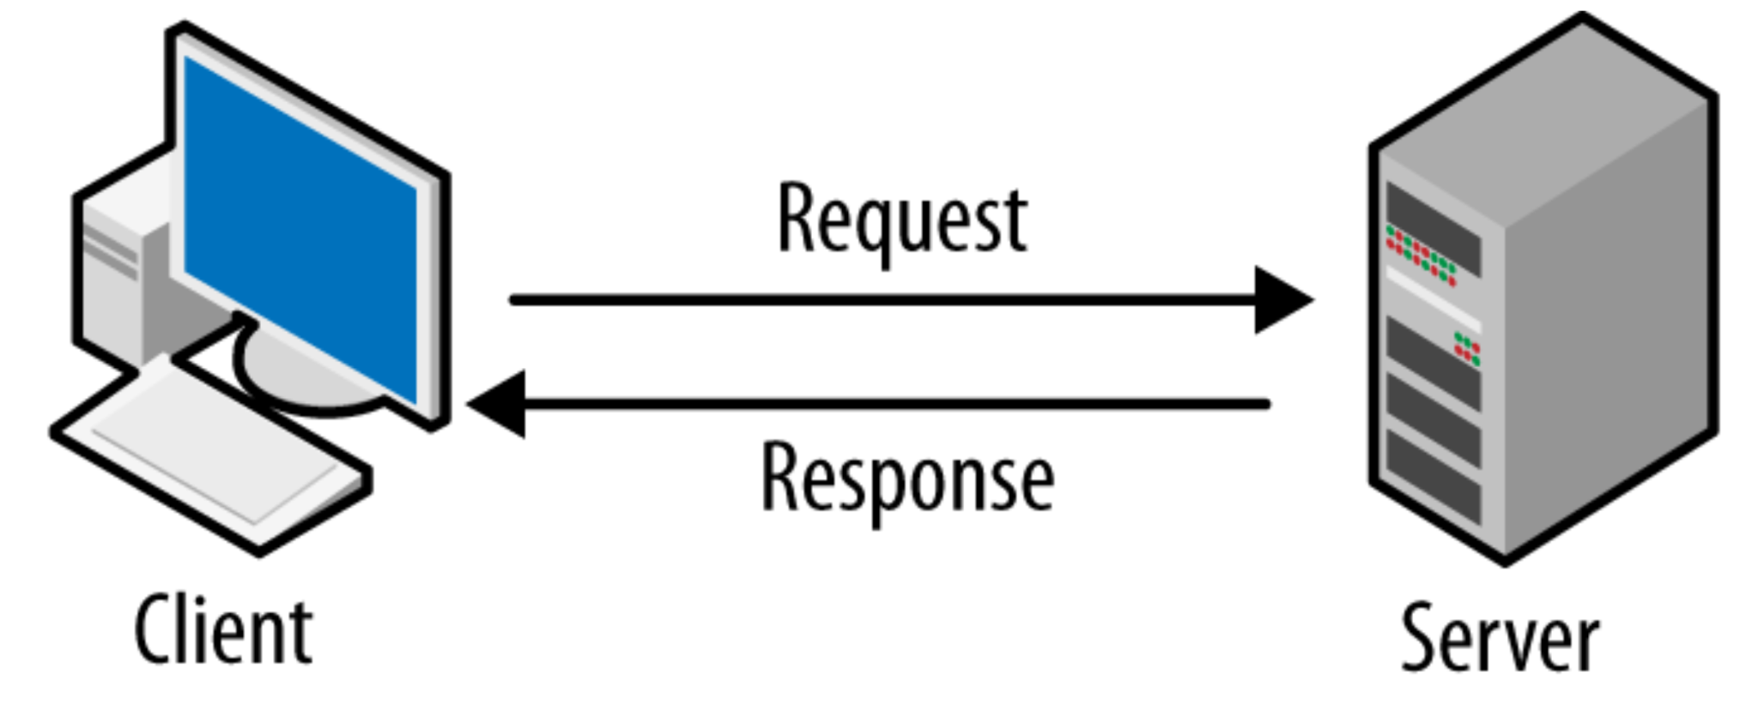

Figure - Client Server

## 3.2 System components

### 3.2.1 Cloud computing

Cloud computing [14] is a form of computing where data and resources are stored, accessed, and managed over the internet instead of on local servers or personal computers. By using cloud computing, businesses and individuals can store, access, and manage data and applications over the internet. Cloud computing can be used to build websites by providing access to web hosting, server-side scripting, and databases. It can also provide access to platform-as-a-service (PaaS) and software-as-a-service (SaaS) solutions that can be used to create web applications. Cloud computing also makes it possible to quickly scale up or down depending on the website's needs.

In our project, to be able to handle such an amount of data storage we will use cloud services. Cloud services are designed to provide easy, affordable access to applications and resources, without the need for internal infrastructure or hardware.

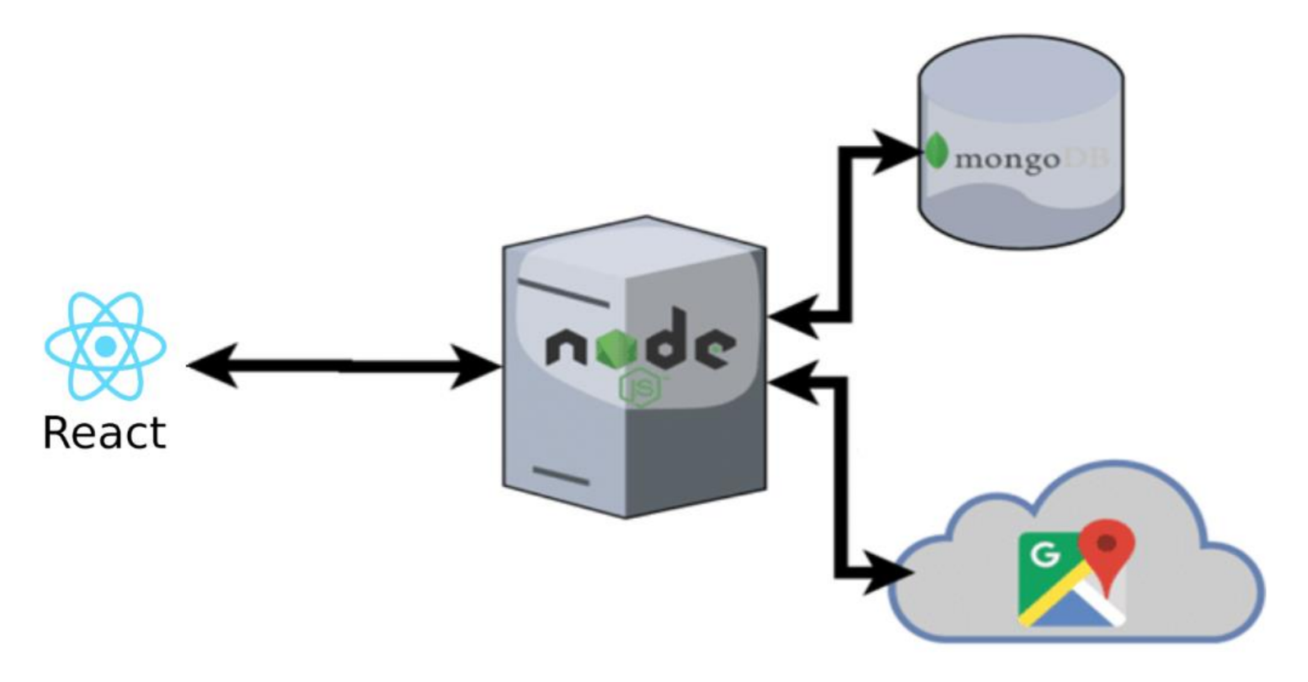

Figure - Architecture and interfaces

MongoDB is a document-oriented database system that uses JSON-like documents with dynamic schemas, making the integration of data in applications easier and faster. It is an open source, cross-platform database system that can be used with React for building dynamic web applications.

Node.js is an open source, cross-platform, JavaScript runtime environment that executes JavaScript code outside of a web browser. It is used for building fast, scalable network applications. Node.js can be used with React to create powerful web applications with responsive user interfaces.

### 3.2.2 MongoDB

MongoDB [12] is a cross-platform database program available from source. Classified as a NoSQL database program. MongoDB uses optional JSON documents and schemas. It supports field, range query and regular expression search. The query can return a specific document field, include a user-defined JavaScript function, and can also be configured to return random samples of a specific size result. MongoDB provides high availability for replicating sets. The replica set is composed of two or more copies of the data. Each member of the replica set can act at any time in the role of the main or secondary replica. By default, all writing and reading is done on the primary replica. Secondary copies maintain the primary data copy using an internal replica. If the primary copy fails, the replica set automatically conducts an election process to determine which secondary copy should become the primary copy. Secondaries can optionally serve read operations, but these data are only ultimately consistent by default.

### 3.2.3 ReactJS

React.js [7] is an open-source JavaScript framework and library developed by Facebook. It is used to build interactive user interfaces and web applications quickly and efficiently. React plays an essential role in the application, handling the application's view layer. React.js encourages developers not to treat the entire user interface as a single unit, but to separate these complex UIs into individual reusable components, which form the entire UI components. In doing so, ReactJS frame works combine the speed and efficiency of JavaScript and more efficient methods for DOM manipulation to make websites faster, create highly dynamic responsive web applications.

### 3.2.4 React Router

In web applications, routing is a process that connects web URLs to specific resources in web applications. React Router [8] is a standard React routing library. It allows you to navigate between different components of the view of the React application, change the browser URL, and keep the UI synchronized with the URL.

### 3.2.5 React Bootstrap

React Bootstrap [10] is a front-end development framework that is widely used. It offers a wide range of UI components that respond to users' needs and can be customized, enabling developers to create visually attractive and interactive web applications effortlessly. React Bootstrap simplifies the development process by providing pre-built components such as navigation bars, buttons, forms, modes, and many others, all with built-in responsiveness and cross-browser compatibility. Furthermore, the React component architecture makes it possible for developers to efficiently manage and update the state of individual components, resulting in modular and reused code.

### 3.2.6 Redux

Redux [9] is a state management library commonly used with React and JavaScript applications. It helps manage the state of an application.

As the application grows, it becomes difficult to keep it organized and maintain data flow. Redux solves this problem by managing the application's state with a single global object called Store.

The store holds the entire state tree of the application, and the state can only be modified by dispatching actions. (using a function called dispatch() ).

the 'Reducers' receive the current state and the dispatched action as inputs and return a new state.

Reducers are pure functions, meaning they do not modify the existing state but create a new state object.

### 3.2.7 Node.js

Node.js [11] is a single-threaded, open-source, cross-platform runtime environment for building fast and scalable server-side and networking applications. It`s allows developers to execute JavaScript code on the server, enabling them to build server-side applications using the same language as the client-side.

### 3.2.8 Express.js

Express.js [13], a minimalistic and flexible web application framework, is built on top of Node.js. It simplifies the process of creating robust web applications. Express.js allows developers to define routes, handle HTTP requests and responses, and manage middleware to handle various functionalities such as authentication, logging, and error handling.

### 3.2.9 Render

Rendering in React refers to the process of transforming the virtual representation of a user interface into the actual HTML elements that are displayed in a web browser. With React's efficient rendering algorithm, known as Virtual DOM, developers can create dynamic and interactive websites that respond quickly to user actions.

## 3.3 System Engineering Documents

To gather relevant data and insights, a questionnaire was conducted as part of the research methodology. The questionnaire was designed to capture participants' perspectives and opinions on the subject. The collected responses were meticulously analyzed, employing both qualitative and quantitative techniques.

we distributed among people from our work, who are a young population, mostly students, who tend to look for second-hand products among rented apartments.

We chose this target audience in the initial phase because it was the most accessible for us and we could get fast and reliable feedback from it.

Link- [https://forms.gle](https://forms.gle/qD7bgQPAdVg7Y5hb6)

We presented and analyzed the answers that emerged from the questions in the questionnaire in the previous book.

Based on the analysis of the questionnaire answers, various Unified Modeling Language (UML) lists were implemented and presented. UML lists served as a visual representation of the gathered data, facilitating a clear and structured understanding of the research findings.

### 3.3.1 Program structure description and runtime configuration

These are all programs and APIs we used including their versions:

* React version 18.2.0
* React-Bootstrap version 2.5.0
* React-Router version 6.4.3
* React-Redux version 8.0.5
* NodeJS version 16.14.0
* MongoDB version 6.9.0
* Express JS version 4.18.2

## 3.4 UML

### 3.4.1 Use Case Diagram

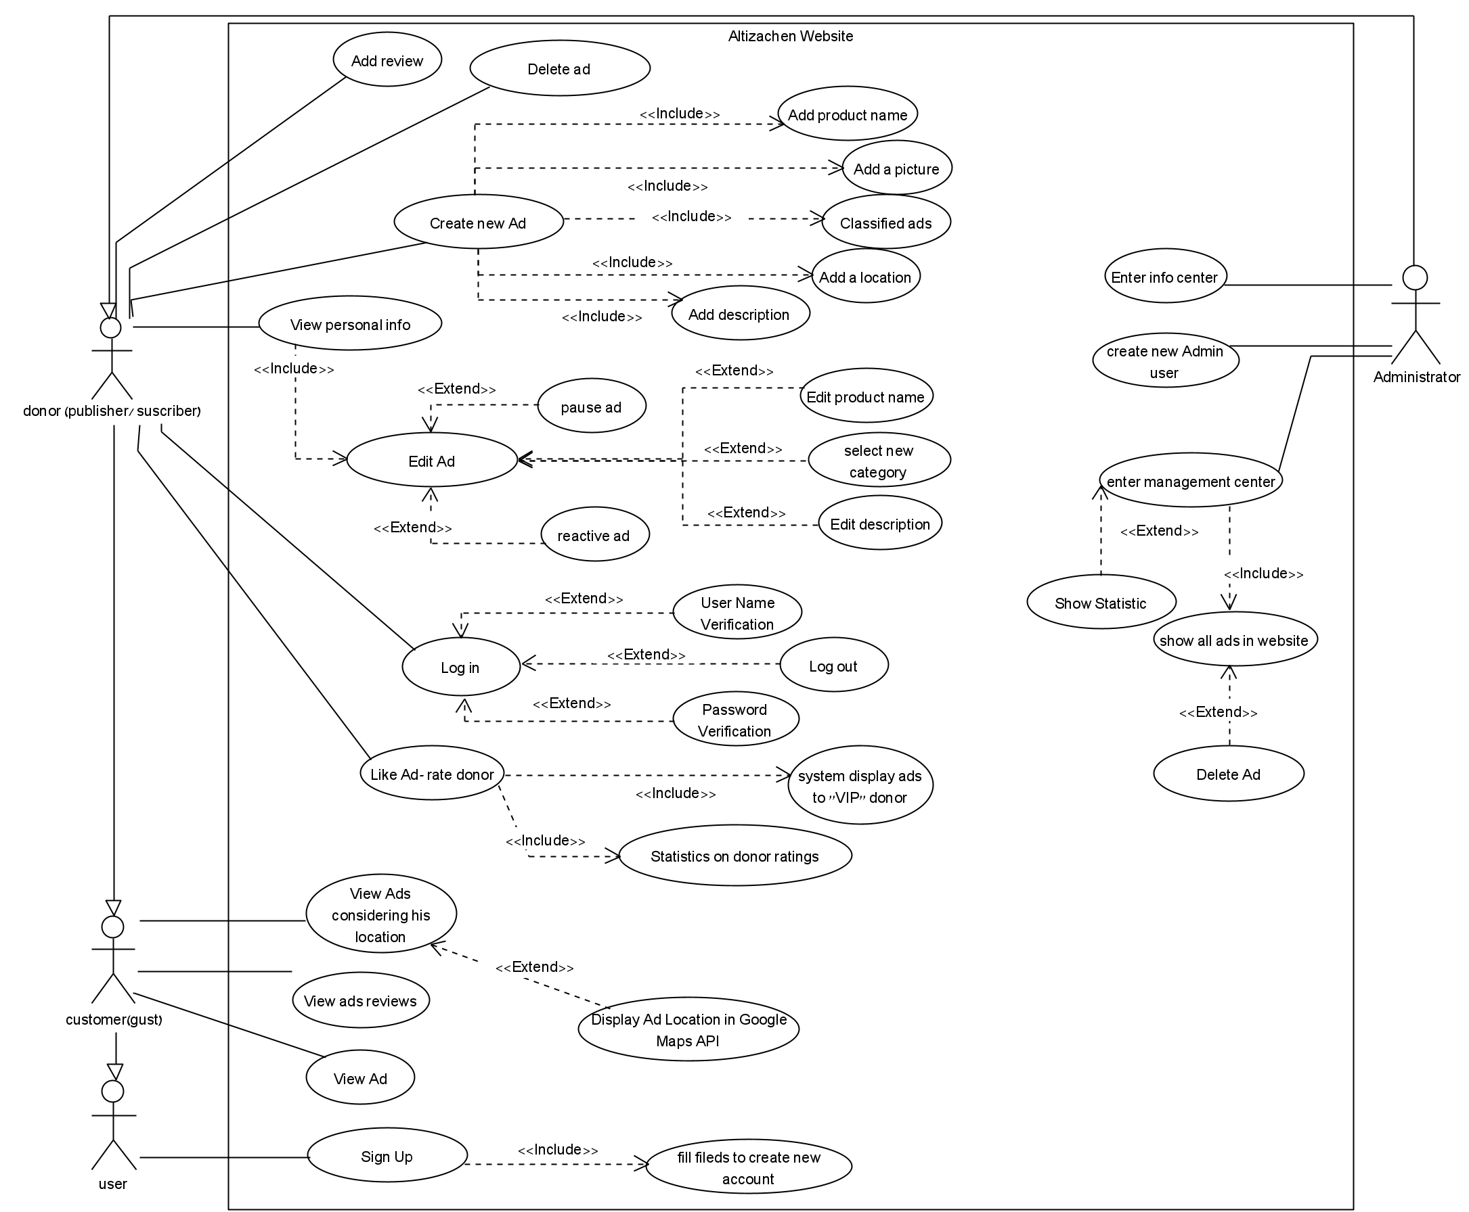

Figure - Use Case Diagram

### 3.4.2 Class Diagram

Figure - Class Diagram

### 3.4.3 Activity Diagrams

#### 3.4.3.1 Upload new product

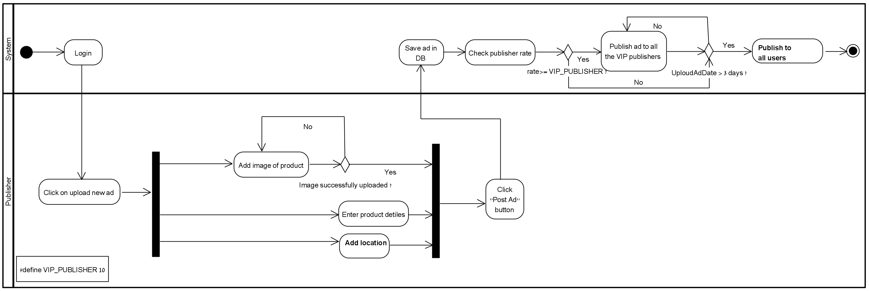

Figure - Upload new product activity diagram

### 3.4.3.2 Edit product

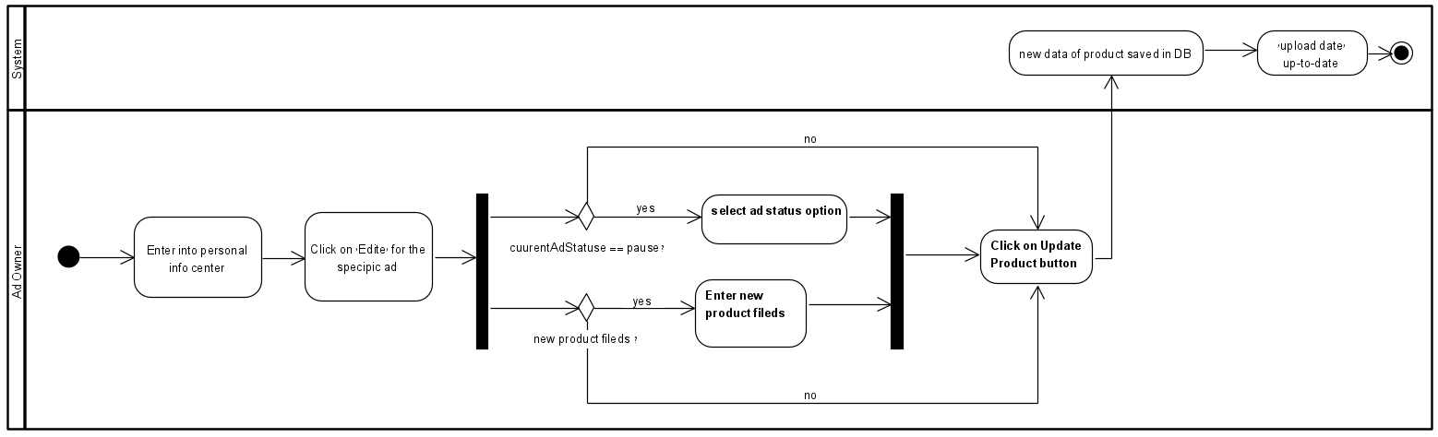

Figure - Edit product activity diagram

## 3.5 System requirements

### 3.5.1 Login

#### 3.5.1.1 Login by gust user

This user type is currently unregistered on the "Altizachen" website. To create a new user, he must click on the “Sign up/Log in” button and in the new window that opens, click on the "Register" button.

* The system allows users to access the login page to initiate the login or sign-up process.
* The system allows uses filling registration form.
* The system allows users to inset the following details: username, email, password, and phone.
* The system securely stores and encrypt user sign up credentials to protect sensitive information.
* The system validates the uniqueness of the chosen email address and username during the sign-up process.
* The system provides appropriate error messages if any required sign-up information is missing/invalid.
* The system detects a wrong email without using the @ pattern, will send an appropriate message and will not create a new user.
* The system requires mandatory fields for all the fields of the website registration form.

#### 3.5.1.2 Login by registered user

* The system allows users to enter their registered email or username.
* The system validates the entered credentials against the stored user data.
* The system provides appropriate error messages for incorrect login credentials.
* The system enforces secure password policies, such as minimum length, complexity, and password expiration.
* The system protects against brute-force attacks by implementing account lockouts or rate limiting.
* The system allows users to have the ability to log out of the session and end the authenticated access.
* The system provides secure communication using encryption protocols.

#### 3.5.1.2 Login by Administrator

* The system allows the administrator all the capabilities available to a registered user.
* The system allows the manager to add a new manager by clicking the Create new manager button.
* The system allows adding another administrator only by a user who is already an administrator.
* The system saves the new administrator's data on the server and allows him access to all the administrative activities available for this user.

### 3.5.2 Flow processes on the website and user’s actions

#### 3.5.2.1 Create a new ad.

* The system allows only to registration user to create new ad.
* The system allows user to access to "Create New Ad" page on "Altizachen" website by click on a the “Upload new ad” button.
* The user to enter relevant details for the new ad, such as title, description, category, price, and location.
* The system validates the input for create new ad and ensure that required fields are filled in.
* The system allows to handle the storage and retrieval of uploaded image.
* The system allows the user to receive confirmation or notification upon successful creation of the ad.
* The system generates a unique identifier or reference number for the created ad.
* The system stores the ad details in a database or persistent storage for retrieval and display.
* The system allows user to delete the ad.

#### 3.5.2.2 Edit an ad.

* The system allows user to access the "Edit Ad" feature for a specific ad on the " Altizachen" website by click on a the “Personal info” button.
* The system allows user to modify the existing details of the ad, such as title, description, category, price, and location.
* The system allows validate the edited information and ensure that required fields are filled in.
* The system allows user to adjust ad settings, such as visibility (pause = not display, active = display) and updating date.
* The system detects an ad that is currently in "pause" status and requires you to select a new field for the current ad as a mandatory field.
* The system recognizes an ad with an "active" status and does not require this field to be a mandatory field.
* The system updates the ad upload date every time the ad editing data is saved.
* The system allows user to receive confirmation or notification upon successful editing of the ad.
* The system to update the ad details in the database or persistent storage for accurate retrieval and display.

#### 3.5.2.3 View ad.

* The system allows the user to view ad details by clicking on the image or the name of the ad.
* The system saves each ad according to its category.
* The system displays all the ads in a certain category in the relevant category in the list on the left.
* The system check if 3 days pass since the moment the ad was uploaded/edited then the ad changes to PAUSE status.
* The system asks the user for permission to use the IP address.
* The system displays all the ads sorted from the closest to the furthest according to the geographical location of the user who is currently viewing the site.
* The system interfaces with the Google Maps API.
* The system allows the user to see the path from the point where he is to the product by clicking on the "View on map" button.
* The system displays the distance from the user to the product location and the expected arrival time.
* The system allows the user to view the ad content and media in a user-friendly and accessible format.
* The system allows the user to have the option to enlarge or zoom in on ad location for better visibility.
* The system allows the user to navigate back and forth between viewed ads or category listings.
* The system allows only a registered user who liked a certain ad to mark it by pressing the "LIKE" button of the system.
* The system allows all types of users to see the amount of likes for each ad.
* A system allows all types of users to view the responses of each ad.
* The system allows a registered user to comment on an ad.
* The system publishes the responses of the ads after clicking "POST".
* The system displays the name of the publisher of the response and the content of the response for each ad.
* The system allows the user to view phone number of the contact person (ad`s owner) and to coordinate the time of product collection.

#### 3.5.2.4 Admin management

* The system detects that an administrator is connected and shows him the "Admin management" button in the main menu.
* The system allows the administrator to enter the admin center page by clicking on the "Admin management" button in the main menu.
* The system presents the administrator with statistics for managing and monitoring the ads and users on the site.
* The system allows the administrator to delete any ad that exists on the site.

#### 3.5.2.4 Rating system

* The system calculates a user rating after each click on the LIKE button for the user who owns the ad.
* The system updates the user rating data inside the ad after clicking LIKE.
* The system recognizes when a registered user with a VIP rating is connected to the website and shows him an additional screen called "VIP ads" on the main screen.
* The system assigns a VIP user as a user whose rating is greater than 60%.
* The system will post a new ad created on the site to all users who are rated as VIP after 1 day the ad will automatically be displayed at the "All Active Ads" layer. according to the field: upload time.

#### 3.5.2.4 Personal info

* The system displays all account information about the user on the personal information screen.
* The system shows the user his personal rating.
* The system shows the user a window with a reminder message to check the ads in pause status upon entering the personal info screen page.

## 3.4 GUI Design

|  |
| --- |
| A registered user can click on the "sign in" button and enter the next page, in case he does not enter requested fields, he will be shown a message as described in the picture:    Figure sign in screen- error message    Figure Registration screen |

|  |
| --- |
| In case this user is already exist:    Figure create new user - error message |
| In case of typing email address incorrect format:    Figure Sign In -error incorrect format message |

|  |
| --- |
| Figure Access the user's location by IP |
| All ads are sorted by distance from the user current location, displayed from closest to farthest location:    Figure sorted ad by locstion |

|  |
| --- |
| A user with a rating lower than VIP will not see the VIP ads screen:    Figure Home screen for not VIP user |

|  |
| --- |
| Home screen display for VIP user and admin:    Figure Home screen for VIP/Admin - all active ads    Figure Home screen for VIP/Admin - VIP ads |

|  |  |
| --- | --- |
| View ad:  The LIKE button appears below the ad`s details affect the rating of the ad publisher.  The rating reflects to all surfers the credibility of the advertiser. A user with a high rating indicates a reliable user - a figure that can help other users.    Figure View ad | |
| Figure View ad google maps |

|  |
| --- |
| Edite ad screen    Figure Edite ad screen |

|  |
| --- |
| Change “Pause Ad” must change in case the current ad`s status is new pause. In case this ad is active this field is not mandatory.    Figure Edite ad in status of pause |

|  |
| --- |
| When pressing on the “Upload Product” on the menu. The user enters into the upload Product Page and can upload new ad, here it can be seen that description is a mandatory filed and a red message display to user, in case all fields are filled the user click on upload Product button and transfer to the home page.    Figure Upload Product    Figure Upload Product successfully message |

|  |
| --- |
| Enter personal info screen:    Figure personal info screen- alert |
| Figure personal info screen |

|  |
| --- |
| Admin punctuality:  The system aggregates data in statistics that include the amount of ads on the site, number of ads, number of users, the most popular ad and other information that helps in managing the site.    Figure Admin menu |
| Figure Admin management center |
| Figure Admin management center - statistic |

|  |
| --- |
| Admin can create new admin user:    Figure create new admin |
| Figure Mobile view |

# 4 Challenges and solutions

Throughout the project implementation, we encountered numerous challenges that required our attention to achieve the desired functionality.

## 4.1 Presentation of products with a common denominator – category:

To enhance user experience on the website, we implemented an organized display of products based on their common category. Users can easily access products within a specific category from the main page through shortcuts. To achieve this functionality, we defined a "product" entity with a "category" field assigned fixed numerical values representing each category. When creating a new ad, users are presented with a window displaying all available categories for the product. This ensures that users select a valid category and prevents input errors. Displaying ads by category on the main page eliminates the need for users to search extensively. Using JavaScript properties and filtering based on the predefined categorical value, we effectively present products within their respective categories.

## 4.2 Ad structure and user LIKE handling for each ad:

To promote transparency and establish a rating system for the users, we implemented a LIKE button. Users can click this button to improve their ranking on the site based on the number of likes they receive on their ads. To achieve this, we integrated the LIKE button within the ad structure and stored a total like count for each user. Whenever the LIKE button is clicked, a backend request is made using the user's unique identifier (phone number) to update their likes count. To prevent users from liking an ad multiple times, we maintained a list of ads that a user has already liked. If a user attempts to like the same ad again, the button appears disabled.

## 4.3 User rating system

To establish trust and reliability among users on the site, we implemented a user rating mechanism in addition to the option of commenting on ads. The mechanism is based on the number of LIKES received by a user, which serves as an indication of their credibility. When a user clicks the LIKE button on an ad, the rating index of the user who posted the ad is updated. This index value is visible to other users, allowing them to assess the trustworthiness of the user. The index is calculated by dividing the total number of likes received by the user by the total number of ads they have posted. Users with a rating index above a certain threshold are designated as VIP users, granting them early access to new ads and an advantage in acquiring new products.

## 4.4 As`s reviews structure:

To efficiently store user comments while maintaining organization, we created a new object of type "ad" to associate comments with their respective ads. We faced challenges in establishing the link between the ad and the user. To overcome this, we implemented a response object type and modified an array to store response variables. Each new comment is added to the comment array along with the user who made the comment, ensuring proper association.

# 5. Evaluation / Verification Plan

In order to test and evaluate our system, we selected to perform two types of tests:

1. Unit testing - Testing individual modules.

2. Functionality testing - Testing the functionality as per user requirements.

## 5.1 Unit Tests

| # | Subject | Test Name | Test Plan | Expected Result | Status |
| --- | --- | --- | --- | --- | --- |
| 1 | Add New Product | Unsuccessfully create new ad. | Adding a new ad without an image. | Failed to create a new ad.  Red error message displayed to the user. | Pass |
| 2 | Unsuccessfully create new ad. | Adding a new ad without selecting a category | Failed to create a new ad.  Red error message displayed to the user. | Pass |
| 3 | Successfully create new ad. | 1. fill all the required fields.  2. click on “Upload Ad” button | New ad created on the website.  The amountOfAd for the owner and updated respectively. | Pass |
| 4 | Registration | Unsuccessfully Sign In | 1. set password in the first field.  2. set not matching password in the second field.  3. click on the “sign In” button. | Red error message displayed on the screen. | Pass |
| 5 | Sign In | 1. verify that all required fields are empty.  2. click on the “sign In” button. | Red error message displayed on the screen. | Pass |
| 6 | Successfully Login | 1. set valid email.  2. set a valid password.  3. click on the “sign In” button. | The user enters the site successfully and his details are displayed at the top of the left site with his user`s name. | Pass |
| 7 | Rate donor | Successfully rating donor | 1. Log in as a registered user and.  2. Open any active ad and click on the LIKE button. | Like button is disabled and the user`s rating updates in the current ad. | Pass |

Table Unit Test

## 5.2 Functionality testing

| # | Test Plan | Expected Result | Status |
| --- | --- | --- | --- |
| 1 | Enter correct Login details and press on the Login button. | The screen switches from login page to home page. the user details display at the top of the site. | Pass |
| 2 | Unsuccessfully create a new ad:  Users can not create a new ad without a picture.  1. upload an image.  2. fill all the required fields.  3. write a description of the product.  4. delete an image.  5. post Ad. | Red error message displayed on the screen. | Pass |
| 3 | Successfully create a new ad:  1. upload an image.  2. fill all the required fields.  2. write a description of the product.  4. post ad | New ad has been posted and the ad displays at the home screen. | Pass |
| 4 | personal info:   |  |  |  | | --- | --- | --- | | 1 | 1.Enter to personal info screen  2. Click on the "Edit ad" button.  3. Select "Not Display" status at “Pause ad” field  4. Click the “Update Product” button. | Verify ads are **not** displayed on the main home screen. | | 2 | 1.Enter to personal info screen  2. Click on the "Edit ad" button.  3. Click the “Update Product” button. | The message “This ad is not- active, you need to fill status in "Pause" field!“ display for user. | | 3 | 1. Select "Display" status at “Pause ad” field  2. Click the “Update Product” button. | Verify no error message is displayed and the ad is displayed on the home screen at the ‘All Active Ads” layer. | | | Pass |
| 5 | Add new review: click on ad and add new command, click send. | Verify the new command display below the ad details. | Pass |
| 6 | Rate a donor:  Preliminary step - create a new user in the system by signing in and publish a new ad successfully.  1.Enter form another user and view the ad from the preliminary step.  2. Click on the “LIKE” button.  3. repeat step 1 from 3 different users on the same donor from the preliminary step.  4. Enter into the personal info screen of the new user who is the owner of this new ad. | The rating of the ad is displayed on the ad.  The user's rating has increased accordingly. | Pass |
| 7 | 1. Enter the site through a registered user.  2. Enter into the personal info screen.  3. Click on Delete Ad. | Verify a confirm window which with the message “Are you sure to delete?” display and ask for confirmation.  Verify the ad not displayed at the website after pressing “OK”. | Pass |
| 8 | Preliminary step - choose to edit ad is status “ACTIVE” and with upload time that is not the current day.  1. Enter the site with a registered user.  2. Enter into the personal info screen.  3. Click on Edit Ad.  4. Click the “Update Product” button without fill any fields. | Verify all the fields of the ad did not change and the date has been updated to the current day. | Pass |
| 9 | 1. Enter the register page.  2. Enter address email without ‘@’.  3. Click on the “register”. | Show an error message. | Pass |
| 10 | Enter into the “Design Products” category. | Verify all products of this category are displayed. | Pass |

Table Functionality Tests

# 6. References

[1]. Trello usage- <https://support.atlassian.com/trello/docs/what-is-trello/>

[2]. SourceTree - <https://www.globallogic.com/services/offerings/atlassian/sourcetree/>

[3]. Agile Method- Cammin, P., Heilig, L., & Voß, S. (2021). Assessing requirements for agile enterprise architecture management: A multiple-case study.‏

[4]. Yad2 - website and application for selling products, tickets and more.

<http://www.yad2.co.il>

[5]. Fraj, E., & Martinez, E. (2007). Ecological consumer behavior: an empirical analysis. International journal of consumer studies, 31(1), 26-33.

[6]. Haraldsson, F., & Peric, S. (2017). Drivers and motivations for second-hand shopping: A study of second-hand consumers

[7]. ReactJS- [https://reactjs.org](https://reactjs.org/)  
[8]. React Router- <https://reactrouter.com/en/main>  
[9]. Redux- <https://redux.js.org/>  
[10]. React-Bootstrap- <https://react-bootstrap.github.io/>  
[11]. NodeJS- <https://nodejs.org/en/>  
[12]. MongoDB- <https://nodejs.org/en/>  
[13]. Express JS- <https://expressjs.com/>

[14]. Cloud Computing-<https://azure.microsoft.com/en-us/overview/what-is-cloud-computing>